Disabled all of the string options until String search is selected.
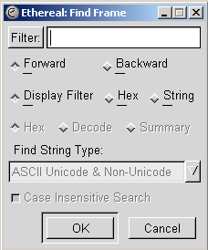

When you click on the String radio button then the string options will enable.
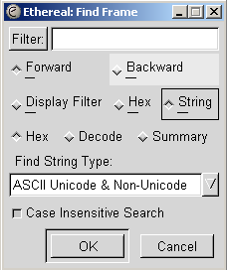

The default is to search the Hex Window (Bottom Window) for data. The find string types only apply to the hex window search since the Decode and Summary windows only show standard text. Click on the Decode radio button to search the Decode Window (Middle Window) for data. This would include any data present in the decode window. Click on the Summary radio button to search the Info column of the summary window (Top Window).

Also note: Case Insensitive Search is enabled by default. This means that NDS and nds will match. If you want to search by case then un-click the Case Insensitive Search button.

Once you have initiated a find. You can then use <Ctl-N> to find next or <Ctl-B> to find previous.

